LAB EXPERIMENT RECORD
Set 28: Vehicle Performance Analysis

Department | AIML
Course Code / Course Name | DSA0601 / Data Handling and Visualization
Experiment | Data Visualization using R and Dashboard Design
Name | G. GANGA CHANDRIKA
Register Number | 1925260144
Date | 22 October 2026
Day | Thursday

Aim
To analyze vehicle performance data using a violin plot, a scatter plot, and a correlation heatmap in R, and to build an interactive dashboard with filters for Engine_Size and Safety_Rating that highlights vehicles balancing fuel efficiency and performance.
Dataset: Vehicle Performance
Vehicle_ID | Engine_Size (L) | Horsepower | Fuel_Efficiency (km/l) | Top_Speed (km/h) | Safety_Rating
V1 | 1.5 | 110 | 18 | 180 | 4
V2 | 2.0 | 150 | 15 | 200 | 5
V3 | 3.0 | 250 | 12 | 250 | 5
V4 | 2.5 | 200 | 14 | 220 | 4
V5 | 1.8 | 130 | 17 | 190 | 3

PROGRAM 1: Violin Plot of Fuel Efficiency by Safety Rating
Develop a violin plot to compare the distribution of Fuel_Efficiency across different Safety_Rating categories. Examine the spread, central tendency, and variability within each group.
# Create the vehicle dataset
vehicle <- data.frame(
Vehicle_ID = c("V1", "V2", "V3", "V4", "V5"),
Engine_Size = c(1.5, 2.0, 3.0, 2.5, 1.8),
Horsepower = c(110, 150, 250, 200, 130),
Fuel_Efficiency = c(18, 15, 12, 14, 17),
Top_Speed = c(180, 200, 250, 220, 190),
Safety_Rating = c(4, 5, 5, 4, 3)
)
# Display the dataset
print(vehicle)
library(ggplot2)
ggplot(vehicle, aes(
x = factor(Safety_Rating),
y = Fuel_Efficiency,
fill = factor(Safety_Rating)
)) +
geom_violin(trim = FALSE) +
geom_jitter(width = 0.08, size = 3) +
labs(
title = "Fuel Efficiency by Safety Rating",
x = "Safety Rating",
y = "Fuel Efficiency (km/l)",
fill = "Safety Rating"
) +
theme_minimal()
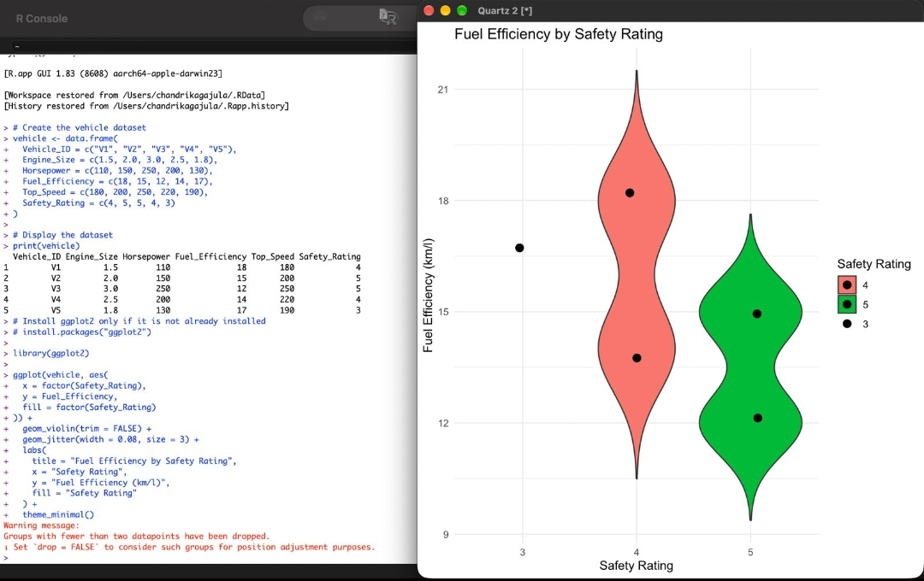
Output 1: Fuel Efficiency by Safety Rating (Violin Plot)
Observation: Rating 3 has only one vehicle (V5, 17 km/l), so it appears as a single point and R drops its violin with a warning. Rating 4 contains V1 (18 km/l) and V4 (14 km/l), giving a mean of 16 km/l and the widest spread (range 4 km/l). Rating 5 contains V2 (15 km/l) and V3 (12 km/l), giving a mean of 13.5 km/l and a range of 3 km/l.
Interpretation: Central tendency falls as the safety rating rises (17, then 16, then 13.5 km/l), and variability is highest in the rating 4 group. In this dataset the higher-rated vehicles are the larger, more powerful ones, so they consume more fuel. With only five vehicles, these patterns are indicative rather than conclusive.
PROGRAM 2: Scatter Plot of Horsepower vs Top Speed
Construct a scatter plot to explore the relationship between Horsepower and Top_Speed, using color to differentiate Engine_Size.
library(ggplot2)
ggplot(vehicle, aes(
x = Horsepower,
y = Top_Speed,
color = Engine_Size
)) +
geom_point(size = 4) +
geom_smooth(method = "lm", se = FALSE, color = "black") +
scale_color_gradient(
low = "blue",
high = "red"
) +
labs(
title = "Horsepower vs Top Speed",
x = "Horsepower",
y = "Top Speed (km/h)",
color = "Engine Size (L)"
) +
theme_minimal()
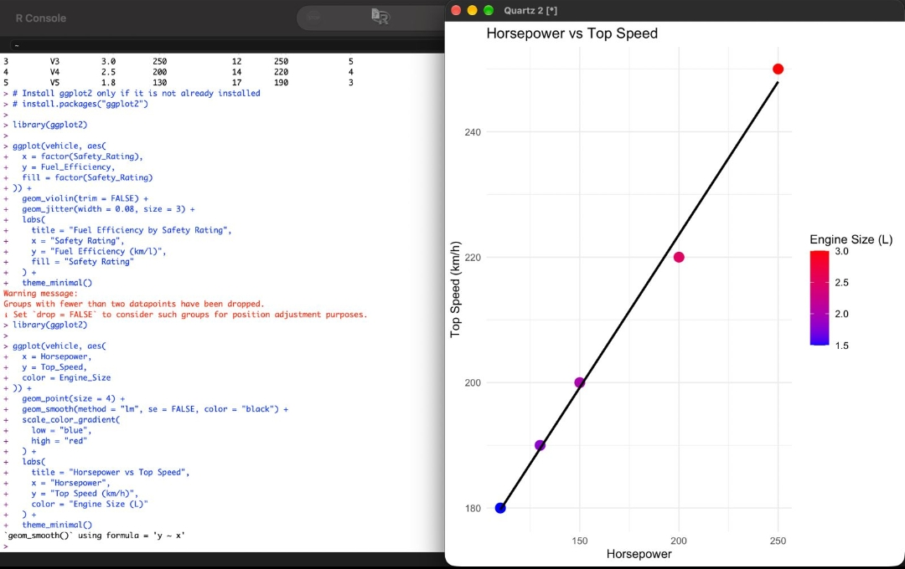
Output 2: Horsepower vs Top Speed Scatter Plot
Insight: The points rise steadily from left to right and lie almost exactly on the fitted line, showing a very strong positive correlation (r = 0.997). The fitted line suggests roughly 0.49 km/h of additional top speed for every extra horsepower. The color gradient shows that engine size increases along the same trend: V1 (1.5 L, 110 hp, 180 km/h) is the smallest and slowest, while V3 (3.0 L, 250 hp, 250 km/h) is the largest and fastest.
PROGRAM 3: Correlation Heatmap of Numerical Variables
Create a correlation heatmap for all numerical variables in the dataset and identify the variables most strongly associated with Top_Speed.
library(ggplot2)
# Select numerical variables
numeric_data <- vehicle[, c("Engine_Size", "Horsepower",
"Fuel_Efficiency", "Top_Speed",
"Safety_Rating")]
# Calculate correlation matrix
cor_matrix <- cor(numeric_data)
# Display correlation values
print(round(cor_matrix, 2))
# Convert correlation matrix into a data frame
cor_data <- as.data.frame(as.table(cor_matrix))
colnames(cor_data) <- c("Variable1", "Variable2", "Correlation")
# Create the heatmap
ggplot(cor_data, aes(
x = Variable1,
y = Variable2,
fill = Correlation
)) +
geom_tile(color = "white") +
geom_text(aes(label = round(Correlation, 2)), size = 4) +
scale_fill_gradient2(
low = "blue",
mid = "white",
high = "red",
midpoint = 0,
limits = c(-1, 1)
) +
labs(
title = "Correlation Heatmap of Vehicle Performance",
x = "Variables",
y = "Variables",
fill = "Correlation"
) +
theme_minimal() +
theme(
axis.text.x = element_text(angle = 45, hjust = 1)
)
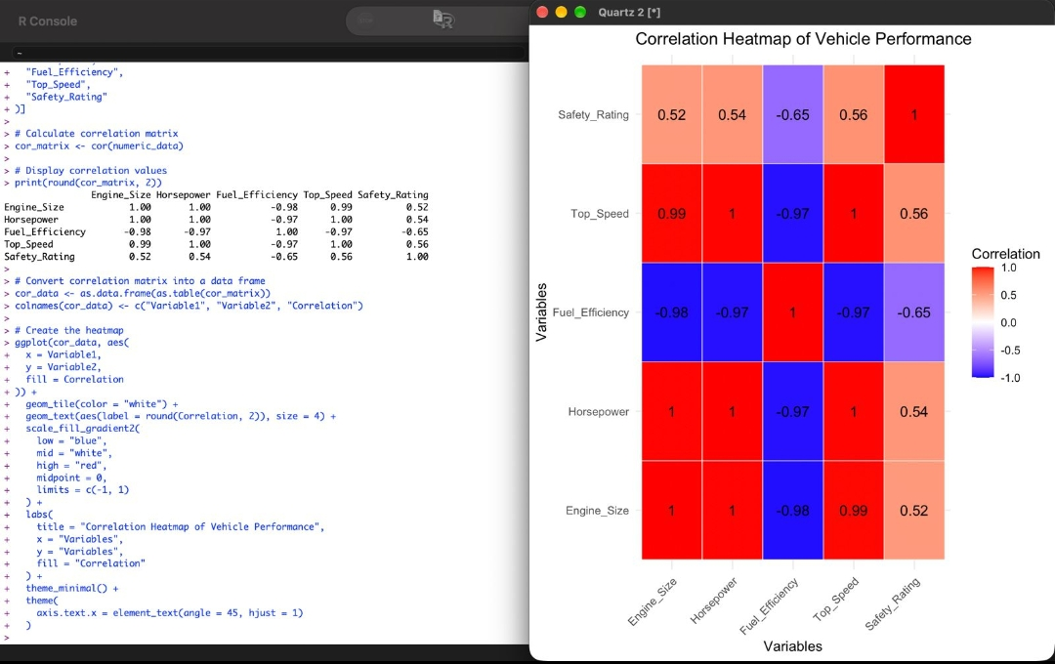
Output 3: Correlation Heatmap of Vehicle Performance
Observation: Top_Speed is most strongly associated with Horsepower (r = 1.00, about 0.997) and Engine_Size (r = 0.99). It has a strong negative correlation with Fuel_Efficiency (r = -0.97) and a moderate positive correlation with Safety_Rating (r = 0.56).
Interpretation: Horsepower and engine size are the main drivers of speed, but the same factors reduce efficiency: Fuel_Efficiency correlates at -0.98 with Engine_Size and -0.97 with Horsepower. Engine_Size and Horsepower are almost perfectly correlated with each other, so their effects cannot be separated. Overall, gaining performance in this dataset comes at the cost of fuel economy.
PROGRAM 4: Interactive Vehicle Performance Dashboard
Design an interactive dashboard with a bar chart and a scatter plot, plus filters for Engine_Size and Safety_Rating, to highlight vehicles that balance fuel efficiency and high performance.
Dashboard components: A bar chart of Fuel Efficiency by Vehicle, a scatter plot of Horsepower vs Top Speed colored by Engine Size and labeled by vehicle, a data table, an Engine Size range slider (1.5 to 3 L), and Safety Rating checkboxes (3, 4, 5).
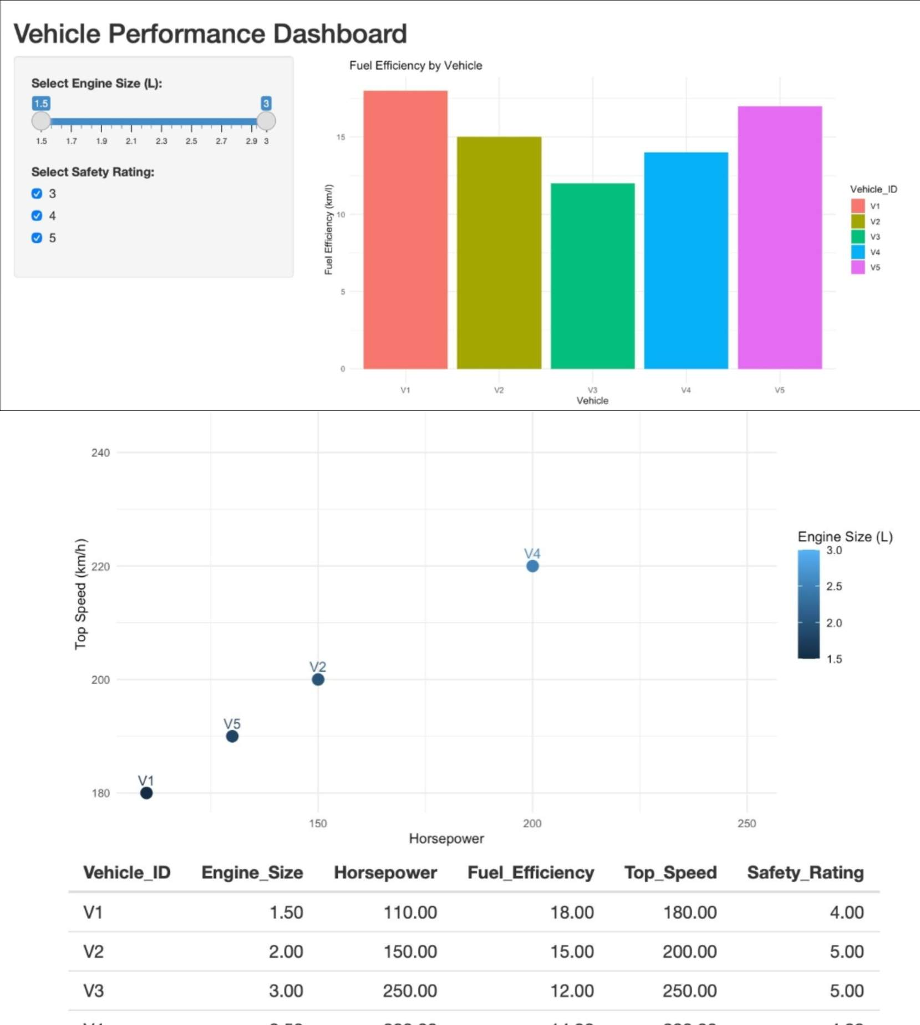
Output 4: Vehicle Performance Dashboard
Insights: V1 is the most fuel-efficient vehicle (18 km/l) but has the lowest top speed (180 km/h). V3 is the fastest (250 km/h) but the least efficient (12 km/l). V2 offers the best balance, combining 15 km/l, a 200 km/h top speed, and the highest safety rating of 5. V5 (17 km/l, 190 km/h) and V4 (14 km/l, 220 km/h) sit between the extremes. Adjusting the filters narrows the view, for example showing only safety rating 5 leaves V2 and V3, which makes the efficiency-versus-performance trade-off easy to compare.
Procedure
1. Create the vehicle data frame with the five vehicles in R and load the ggplot2 package.
2. Use geom_violin() and geom_jitter() to compare Fuel_Efficiency across Safety_Rating categories.
3. Use geom_point() and geom_smooth(method = "lm") to plot Horsepower against Top_Speed, with color mapped to Engine_Size.
4. Select the numerical columns, compute the matrix with cor(), convert it using as.table(), and draw the heatmap with geom_tile().
5. Build the dashboard with a fuel-efficiency bar chart, a horsepower vs top-speed scatter plot, and filters for Engine_Size and Safety_Rating.
6. Apply the filters and interpret which vehicles balance fuel efficiency and performance.
Result
The vehicle performance data was successfully visualized using a violin plot, a scatter plot, and a correlation heatmap. Fuel efficiency decreases as engine size and horsepower increase, while top speed is almost perfectly correlated with horsepower and engine size. The interactive dashboard highlighted V2 as the vehicle with the best balance of efficiency, performance, and safety.
Key R Functions Used
Function | Purpose
data.frame() | Creates the vehicle dataset.
ggplot() | Initializes a ggplot with data and aesthetic mappings.
geom_violin() | Draws the violin plot of fuel efficiency.
geom_jitter() | Overlays the individual data points.
geom_point() | Draws the scatter plot points.
geom_smooth() | Adds the linear regression line.
cor() | Computes the correlation matrix.
geom_tile() | Draws the heatmap cells.
scale_fill_gradient2() | Sets the blue-white-red diverging color scale.

